1 – How to access to FIGMA online

2 – How to access on Figma in your computer?

3 – What is the purpose of Figma?

4 – What are the difference between Figma vs. Adobe XD

5 – How to design poster using figma

6 – How to design website mock up using figma?

7 – How to design mobile app mock up using figma

8 – How to make the demo mobile apps navigate from one page to another page

9 – How to make a navigate from one page to another page in website mock

10 – How to install and use plugin in Figma

11 – How to download library to use in Figma

12 – How to export file in Figma to image file

13 – How to share your work to your friends in Figma

**Project – 1**

Design Your poster using figma

* Poster include your teammate picture
* Choose some color
* Draws some shape and add some text

Example:



**Project – 2**

Design website mock up

* 3 pages at least
* Each page contains some picture and text
* Choose color of your mock

Example:

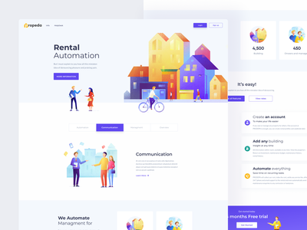

**Project – 3**

Design mobile mock up

* 3 screens at least
* Each screen contains text and image

Example:

